# **Effect on Library Size on Protein Identification and Quantification timsTOF (TimsTOF Pro) by TIMS-DIA-NN**

## Qin Fu and Niveda Sundararaman, Cedars-Sinai Medical Center

**Requirements for TimsTOF Workshop Session**

We will perform a live demo of analysis using the small library (and display similar results for the large library)

**Input Files:**

The input files can be downloaded from Panorama Web: <https://panoramaweb.org/Instruction/2022%20ASMS%20Workshop/Bruker%20TimsTof%20data/project-begin.view>?

Small library result file: **20221021_SmallLibrary_Clean_Run2_GlabalNomalizationOFF_results.tsv**

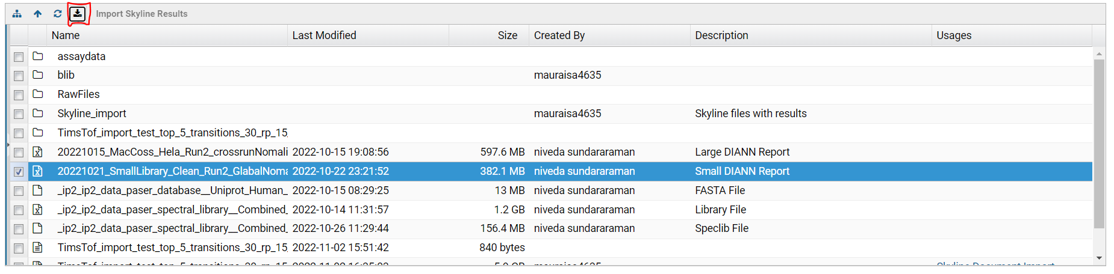

**Setup:**

1. Install R

All the data analysis and visualization were done using the R Programming Language (3.6.3 or above).

R can be downloaded from: <https://posit.co/download/rstudio-desktop/>

1. Install RStudio

RStudio can be installed from: <https://posit.co/download/rstudio-desktop/>

(C) Packages required:

1) dplyr: install.packages("dplyr")

2) tidyverse: install.packages("tidyverse")

3) ggplot2: install.packages("ggplot2")

4) RColorBrewer: install.packages("RColorBrewer")

5) Hmisc: install.packages("Hmisc")

Installing R packages: <https://datatofish.com/install-package-r/>

**R script for Visualization:**

Download R script we will use in the Workshop Demo from here:

<https://github.com/csmc-vaneykjlab/ASMS-Workshop-TimsTOF-Analysis/tree/main/src/paser_data_analysis_small.Rmd>

To download, right-click “Raw” button on the top-right and select “Save link as”:

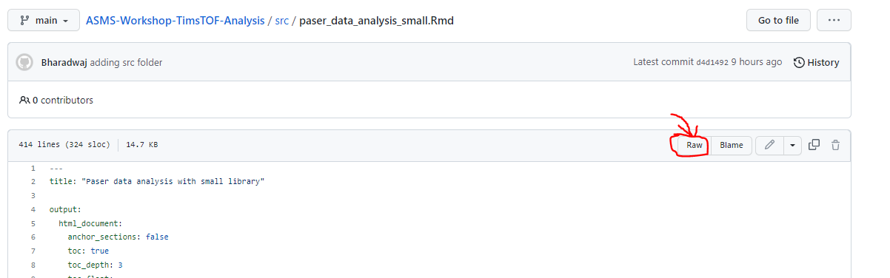

Alternative set up: By downloading the github repository [ After the RStudio set up is complete]

Step 1: Download the zip file from this link: <https://github.com/csmc-vaneykjlab/ASMS-Workshop-TimsTOF-Analysis>

Step 2: Extract the zip file to the folder of your choice 🡪 right click on the downloaded file 🡪 extract all 🡪 choose location

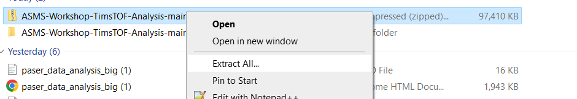

Step 3:

1. Open R studio instance and go to the sessions tab to set working directory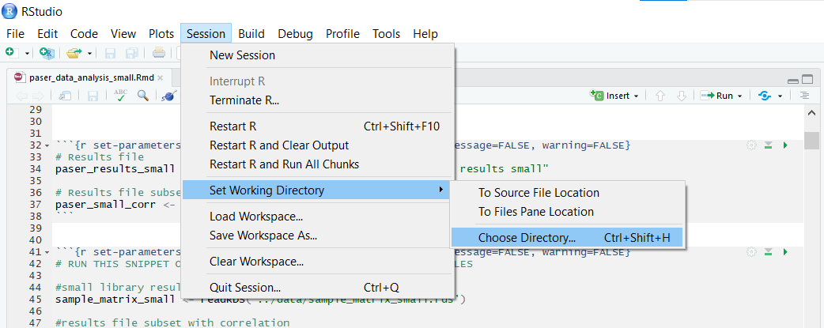
2. Choose the src folder under the extracted folder on step 2 : 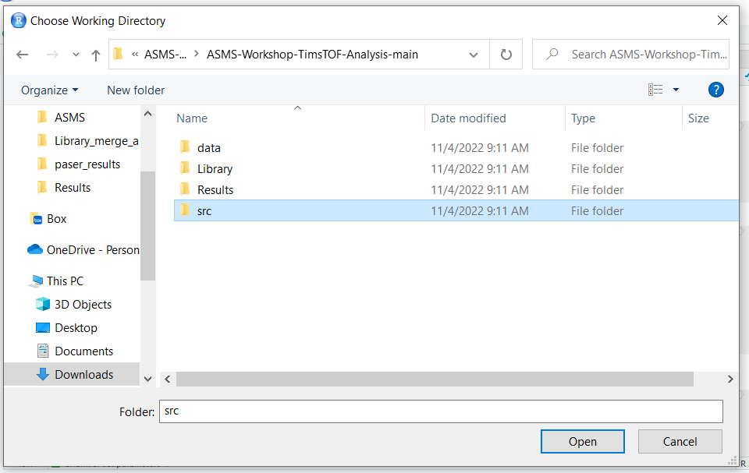
3. On the files pane, on the right hand side. Double click the paser_data_analysis_small.Rmd to open

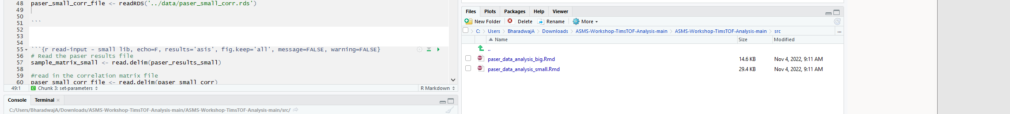

And then, follow along with the demo.

Thank you!